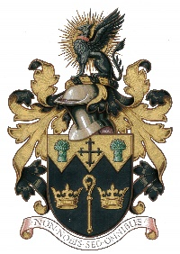
NORTH WALSHAM TOWN COUNCIL

Use of Market Cross Application Form
Organiser:
Nature of Use:
Date/Days: Times:
Risk Assessments, insurance documents and methods statements in place YES/NO (if YES please attach)
NO when will these be available ?
Once the use of the Market Cross is approved, local traders and residents must be notified prior to event
The NWTC General Privacy Statement explains how we use your personal data, store it securely and how you can exercise your rights. All data will be destroyed in line with our Retention & Disposal Policy
Please Note: It is NOT the responsibility of the Town Council to clear up after an activity/event

Terms and Conditions
- The Organiser shall take out adequate Public Liability insurance cover of at least £5 million, and Employer’s Liability insurance cover of £5 million fully indemnifying the Council against accidents or injury to third parties and/or damage to third party property.
- A fire extinguisher appropriate to the activity should be on site during the event
- The Market Cross MUST be left in a tidy condition after the activity, free from litter and other rubbish
- Any advertising MUST be removed after the activity has ended
- The Town Council reserves the right to stop the activity if these terms and conditions, are not followed

Signed: Date:

Email: Phone:
Please return form to - 18 Kings Arms Street, North Walsham NR28 9JX or email to - info@nwtc.org.uk
FOR OFFICE USE
Approved YES/NO Meeting & Date: ______________________________________

