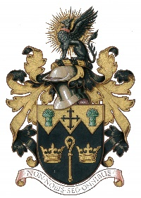
NORTH WALSHAM TOWN COUNCIL

Complaints Form
Adopted by the Council at its meeting held on 26.11.19

Name:
Address:

Post Code:

Details of Complaint:

How you would like to be contacted Email Letter Phone

Contact details:

Have you spoken to anyone at the Council? YES/NO

If YES please give their name:

What outcome are you looking for:

The NWTC General Privacy Statement explains how we use your personal data, store it securely and how you can exercise your rights. All data will be destroyed in line with our Retention & Disposal Policy

Please return form to - 18 Kings Arms Street, North Walsham NR28 9JX or email to - info@nwtc.org.uk

