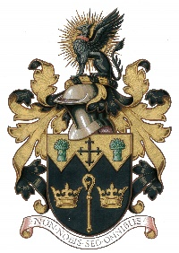
NORTH WALSHAM TOWN COUNCIL

Co-option Form
Adopted by the Council at its meeting held on 29.6.20

Name:
Address:
Post code:
Email: Phone No:
You must declare that you qualify for the following:-
a. | I am over 18 years of age
b. | I am a British Citizen or a citizen of the commonwealth or a citizen of any other member of the European Union with residency
c. | I am registered to vote in North Walsham or have lived/worked in North Walsham (or within three miles of its boundary) in the last 12 months

Under section 80 of the Local Government Act 1972 there are some reasons why a person is disqualified from being a Town Councillor, including these reasons:-
i. | I have not been employed by the Town Council in the last 12 months
ii. | I have not been declared bankrupt
iii. | I have not in the last 5 years been convicted and sentenced to imprisonment
iv. | I have not been disqualified under Part iii of the Representation of the people Act 1983 (relating to corrupt or illegal electoral practices and offences relating to donations)

Please give a personnel statement and any relevant experience for consideration i.e. forward thinking, knowledge of the area, being a team player, representing the community, willing to represent the Council, previous experience, etc.

I declare the information given on this form to be true and correct
Signature: Date:
The NWTC General Privacy Statement explains how we use your personal data, store it securely and how you can exercise your rights. All data will be destroyed in line with our Retention & Disposal Policy
Please return form to - 18 Kings Arms Street, North Walsham NR28 9JX or email to - clerk@nwtc.org.uk

