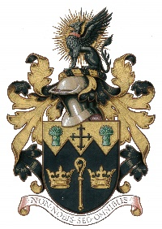
NORTH WALSHAM TOWN COUNCIL

Banner/Advertisement Application Form

Agreed by the D&A Committee at its meetings held on 8.6.20

Name of Organisation/Business:
Representative:
Location to be erected:
Size of Banner/Advertisement:
Date to be erected: Date taken down
Email address: Phone No:
Signed: Dated:

Banners/advertisements, for promoting North Walsham only, they can be displayed for a one month period, twice a year, at a cost of £25 per month (fee may be waived for ‘Not For Profit’ events) . Only 4 Banners will be displayed in one area at any time. Please read the Outdoors Advertising Policy which accompanies this Application Form setting out full details of the conditions relating to placing a banner/advertisement to the Council’s property. Please note in particular the Standard Terms and Removal of Signs.
Payments made to:- Name: North Walsham Town Council, Sort Code: 60:15:54, A/C No. 82546819
If anyone wished to have a permanent Notice Board placed on any of the Town Council properties details can be obtained from the Town Council Office (details below). Details required will be the type of sign, size and wording and the annual charge payable will be provided.
The Town Council will reply to this Application Form within 7 days of receipt with notification of decision by either email or telephone.
The NWTC General Privacy Statement explains how we use your personal data, store it securely and how you can exercise your rights. All data will be destroyed in line with our Retention & Disposal Policy

Please email form to:- info@nwtc.org.uk or post to:- 18 Kings Arms Street, North Walsham NR28 9JX
FOR OFFICE USE
Approved YES/NO Charge £
Meeting & Date: ______________________________________ Signed:__________________________

